J-component : Machine Learning

Review 2

Topic: The Common man’s portfolio management system

## Abstract :

## Current Consumer Needs and Trends:

Financial markets are an attractive place to make money grow. However risk associated with it deter many. This has resulted in nearly 85% Indians stowing away their money in Banks at negligible interest rates. The potential economic power of the savings of these 85% denizens is enormous and Indian economy which has recently entered its growth phase with ‘*Make In India’* project can benefit greatly if this enormous corpus was invested into young and budding industries.

Formally, whenever a company needs money more than a single entity or loan can offer , the go for an IPO (initial public offer), and open their company to investors to hold a share proportional to their(investor’s) investment. This is what we call the share market or the stock market.

Any potential investor can make up to 20% gain on their investments if they invest in the right places. Conversely there is a risk that they might lose all their money if the company claim’s fraud or goes bankrupt.

Our project is initially , a free service for all interested investors who wish to invest money in the stock markets and trade by themselves . Our service would provide them with suitable investments(stock portfolios) based on risks associated with it.

## Our Theoretical Product :

Platform to guide new and inexperienced investors towards making better investment . A website where your investment details would fed through our expert system with a Machine Learning Model under its hood(back-end).

## Working :

* In this particular phase of the project we restrict ourselves to Stock markets only, as data is more easily available. Later we plan to extend the model to bond markets , derivative markets or even more ambitiously the currency market.
* For the above stated back-end or our model, we would use ***recurrent neural network*** , an LSTM algorithm which is the current state-of-art in this field.
* Following the training of stock data from 20 or so stocks , we would use embedding visualization by clustering embedding space in t-SNE(t-Distributed Stochastic Neighbor Embedding) supported by TensorBoard.
* Based on the above identified clusters we would classify the clusters according to ‘Risk aversity’ and profitability. (Pending, as in not implemented yet)
* This classification would be fed into our expert system’s(PyKnow) Rules. (Pending)
* Using these rules a User would be able to receive an accurate advise on which Stock portfolio to Invest . (Pending)

## Implementation using :

* Python 3.6
* Tensorflow 0.9
* Tensor Board for visualization

**Some Images: (experimental data off the shelf)**

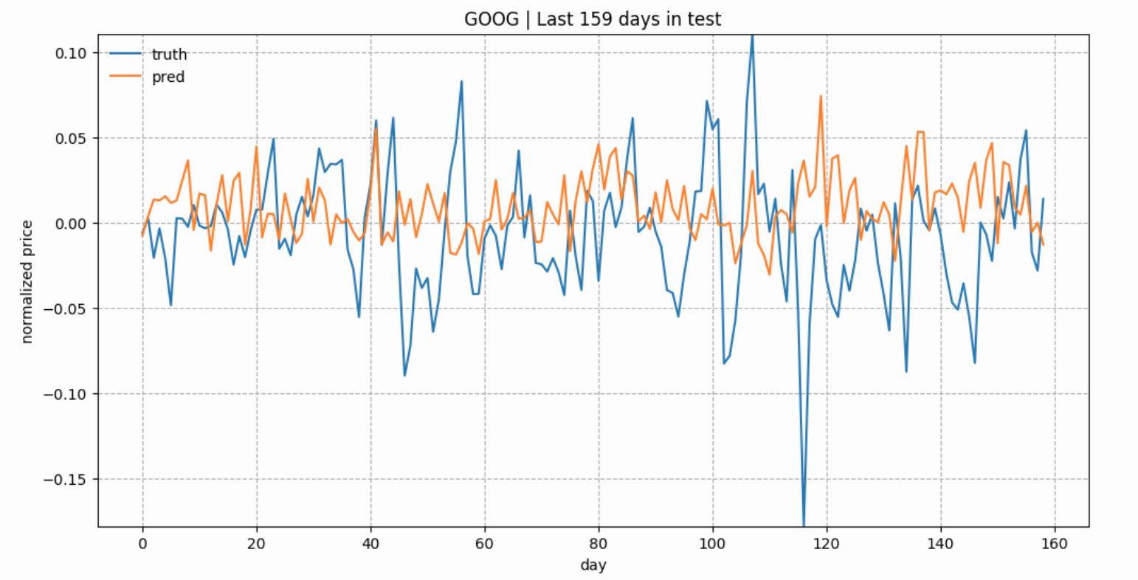

*True and predicted stock prices of GOOG in the test set. The prices are normalized across consecutive prediction sliding windows*

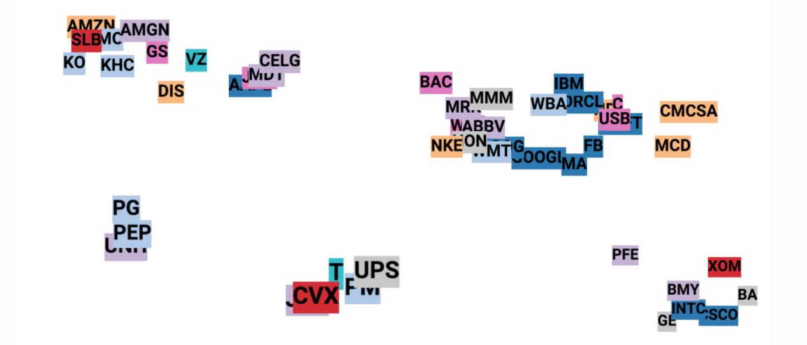

*Visualization of the stock embeddings using t-SNE. Each label is colored based on the stock industry sector. We have 5 clusters. Interstingly, GOOG, GOOGL and FB belong to the same cluster, while AMZN and AAPL stay in another*

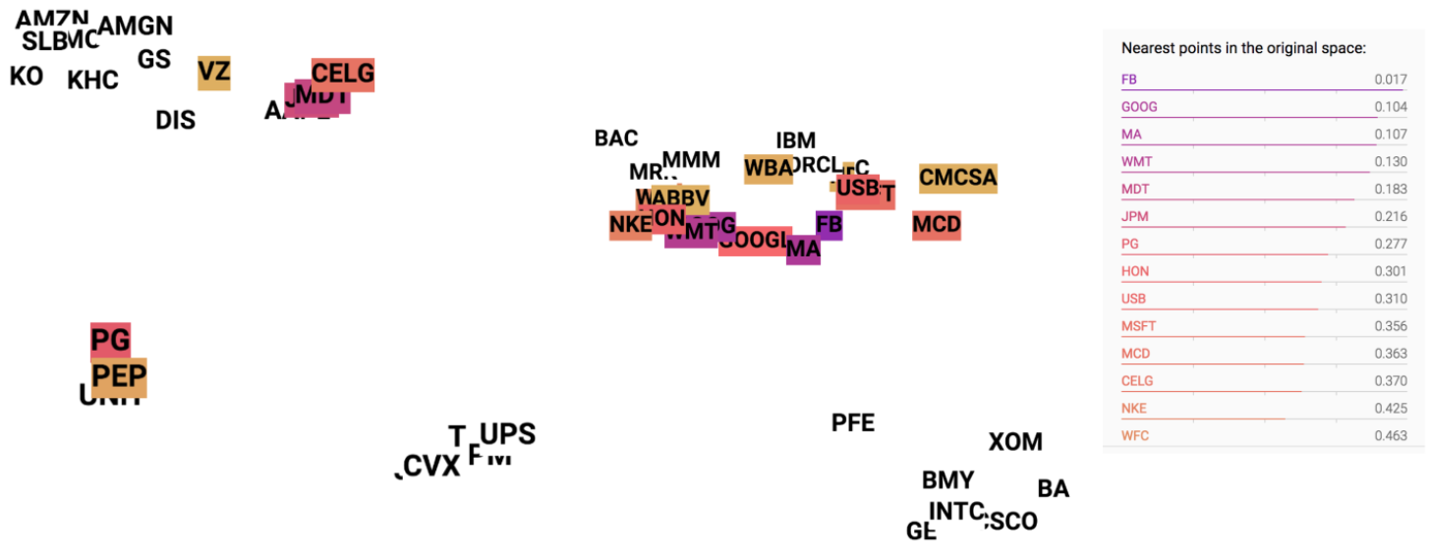

*“GOOG” is clicked in the embedding visualization graph and top 20 similar neighbors are highlighted with colors from dark to light as the similarity decreases.*

**Some references :**

* <https://colah.github.io/posts/2015-08-Understanding-LSTMs/>

This is by far the best blog to understand Recurrent Neural Network .

* <http://monik.in/a-noobs-guide-to-implementing-rnn-lstm-using-tensorflow/>

Tutorial for using RNN on tensorflow

* <https://medium.com/mlreview/a-simple-deep-learning-model-for-stock-price-prediction-using-tensorflow-30505541d877-> Guide on using neural networks on

stock markets.